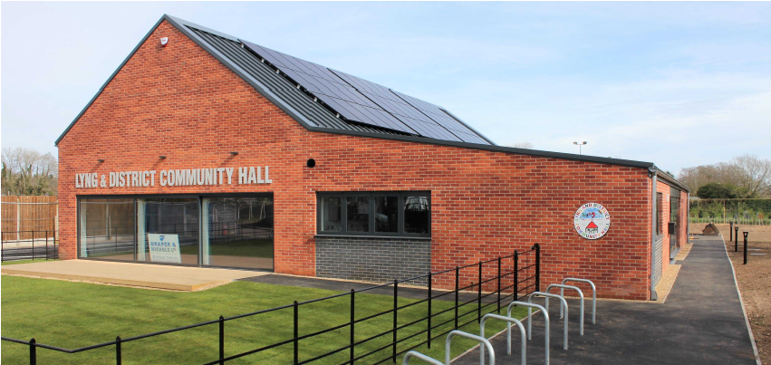
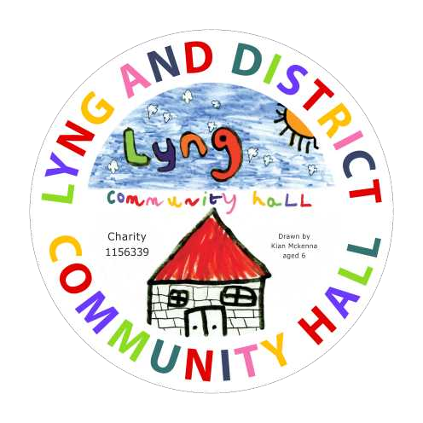
Lyng & District Community Hall

Buy-a-Brick

FUNDRAISING APPEAL
1st December 2026 to 31st March 2027
The hall offers a fantastic space for community groups and private hirers, providing facilities, services, and a socialising space for people of all ages, interest and background.
Please help us to raise money for the upkeep and running costs of the hall. The costs of an etched brick with your name / message is £30.
Please order for me ____ brick(s)
Enter your name or message for your etched brick(s) here (2 lines per brick, 16 characters per line):
Brick 1 Brick 2

__________________________________________ ____________________________________________

__________________________________________ _____________________________________________
For more than 2 bricks please provide the lettering on the back of this sheet.
Please return this form to:
Alan Chapman, 49 Pightle Way, Lyng enclosing your cash / cheque (made payable to Lyng and District Community Hall) or pay by BACs to Barclays Bank, Account name Lyng and District Community Hall - Account number 20595799, Sort code 20-28-20, using your surname as the reference.

Name:________________________________________________ Contact No.: __________________________________
Terms and Conditions
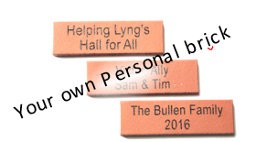
· Buy-a-Brick is an appeal for donations to raise money for the new Hall.
· All etched bricks remain the sole property of Lyng & District Community Hall.
· Lyng Hall reserves the right to approve all lettering and to refuse any application.
· Etched bricks will be displayed on the new Hall for a minimum of 20 years.
· We will not pass on your details to any third parties, nor disclose your donation
should you wish to remain anonymous.
· Lyng & District Community Hall will have complete control over the location and
installation date of the etched bricks.
· Although designed to last, etched bricks may become worn /damaged over time
owing to natural causes. No liability can be accepted for this by Lyng & District Community Hall.
info@lyngvillagehall.co.uk www.lyngvillagehall.co.uk Charity number 1156339

